Vector Databases in MuleSoft: A Postgres + pgvector with Ollama

Author
Subhash Nagula
Contents
1. Introduction 2
2. Architecture Overview 2
3. Environment Setup 3
4. Building the Ingestion Flow (Phase 1) 3
5. Building the Query/Retrieval Flow (Phase 2) 5
6. Observations from the POC 6
7. Conclusion 7

- Introduction
If you've been anywhere near the AI conversation this year, you've heard "RAG," "embeddings," and "vector search" thrown around constantly. What doesn't get talked about enough is where integration platforms like MuleSoft fit into that picture.
Here's the thing: every RAG pipeline, every semantic search feature, every AI agent that needs "memory" or "context" is fundamentally an integration problem. Data has to be extracted, transformed, embedded, stored, and retrieved and that's exactly the kind of orchestration MuleSoft was built for. The missing piece for most of us as MuleSoft developers isn't the platform, it's understanding vector databases well enough to wire them in.
That's what this post is about. Rather than reaching for a dedicated vector database service, I ran a POC using Postgres with the pgvector extension a database most of us already know how to operate paired with Ollama models for generating embeddings. The goal was simple: understand what it actually takes to get vectors into Postgres from a Mule flow, query them back out with similarity search, and see where the real friction points are.
This isn't a theoretical walkthrough. It's a deep, code-level look at the ingestion flow, the retrieval flow, the DataWeave transformations that trip people up, and the SQL that makes similarity search work along with the things that broke, surprised me, or took longer than expected along the way.
If you're a MuleSoft developer curious about where AI-native features actually plug into your existing skill set, this one's for you.
- Architecture Overview
source data → chunking → Ollama embeddings → pgvector storage → Mule retrieval flow → consumer (agent/chatbot/API)
Two phases: ingestion pipeline and query/retrieval pipeline
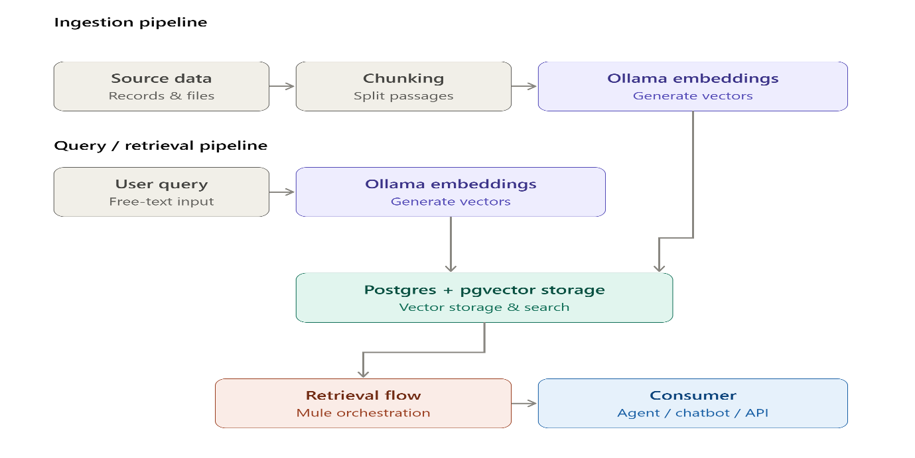

- Environment Setup
This POC runs on PostgreSQL 18 with the pgvector extension enabled as the vector store, and Ollama model as the embedding provider, both integrated through the MuleSoft Vectors Connector.
- PostgreSQL installation: PostgreSQL 18 installed locally via the official Windows installer, with a dedicated database and non-superuser role created for the POC.
- pgvector setup: Since pgvector isn't bundled with the Windows installer, the extension binaries were added separately and enabled per-database with CREATE EXTENSION vector.
- Ollama model connection: Install Ollama in OS and pull any model into it like “nomic-embed-text” (only used for generating embeddings) using powershell commands and provide base URL (default: http://localhost:11434) to prepare the connection.
- PostgreSQL configuration: The database exposes standard host/port/database/user credentials to the connector, with the vector dimension configured to match the embedding model's output size.
- Check check database

4. Building the Ingestion Flow (Phase 1)
Before any similarity search can happen, your raw data needs to be converted into vectors and stored. This is a one-time (or periodic) pipeline that runs before the actual query/retrieval flow. It has five steps:
- Load Data
Pull in the source content you want to make searchable this could be documents, records, PDFs, or database rows. It can come from a local file system, cloud storage like Azure Blob Storage, or Amazon S3. For this POC, we're loading data locally.
- Split/Chunk Data
Large documents are broken into smaller pieces ("chunks") a paragraph or a few sentences at a time. This matters because embedding models work best on smaller, focused pieces of text, and smaller chunks give more precise search results later.
- Embed Chunks (Vectorization)
Each chunk of text is passed through an embedding model, which converts it into a vector a list of numbers that captures the meaning of that text. Several models can do this (Azure OpenAI, OpenAI, Hugging Face, Mistral AI, Ollama, and others). For this POC, we're using Salesforce Einstein as the embedding model.
- Store Vectors
The resulting vectors are saved into a vector store/database, alongside the original text and any metadata. There are many vector store options available (Pinecone, Chroma, Milvus, Qdrant, MongoDB Atlas, and more). For this POC, we're using PGVector Postgres with the pgvector extension.
- End
Once vectors are stored, the indexing phase is complete. The data is now ready to be searched in Phase 2 (the query/retrieval phase).
- Mule Flow:
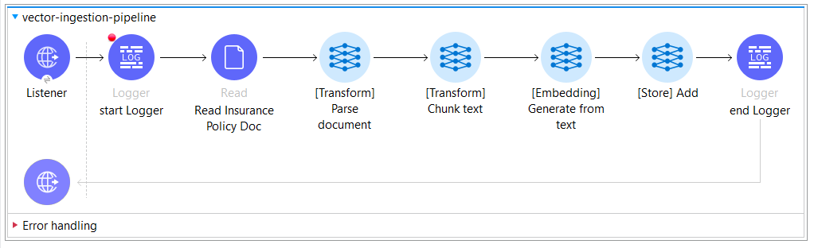
- Ingest document data into vector store and response body after adding to vector store
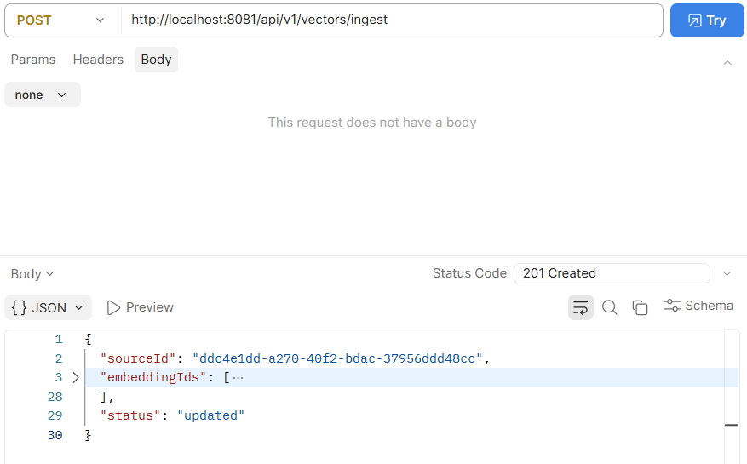
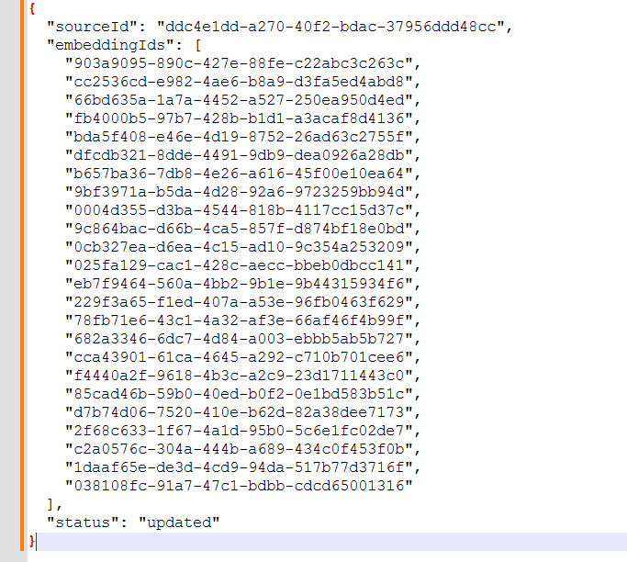

- Building the Query/Retrieval Flow (Phase 2)
Once data is indexed and stored as vectors (Phase 1), this phase handles what happens when a user actually asks something. It runs every time a query comes in, not just once.
- User Query Input
The user submits a natural-language question or search text this is the trigger for the entire retrieval flow.
- Query Embedding
The query text is converted into a vector using the same embedding model used during indexing. This match matters mixing embedding models (e.g. indexing with one model, querying with another) produces meaningless similarity scores, since different models map text into different vector spaces. For this POC, we're using nomic-embed-text via Ollama for both indexing and querying.
- Vector Search
The query vector is compared against all stored vectors in pgvector using a similarity search algorithm. For this POC, we're using the HNSW (Hierarchical Navigable Small World) index it offers faster approximate search at scale compared to flat/exact search, with a small trade-off in accuracy.
- Prompt Construction
The top-matching chunks retrieved from the vector search are assembled into a prompt, combined with the original user query this gives the LLM relevant context to answer from, instead of relying on its own general knowledge.
- LLM Generation
The constructed prompt is sent to a language model, which generates a natural-language answer grounded in the retrieved context. This can be done via the MuleSoft Inference Connector or the Einstein AI Connector. For this POC, a chat-capable model would be needed here separate from the embedding-only model used in steps 2 and 3. So I have used an chat capable Ollama model called llama3.2.
- End
The generated response is returned to the user, completing the RAG cycle.
- Mule Flow (RAG + LLM)
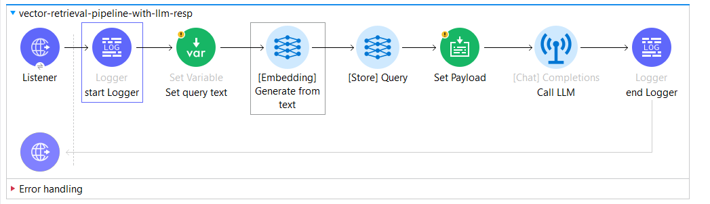
- HTTP request from user to retrieve required details from document data stored with a query
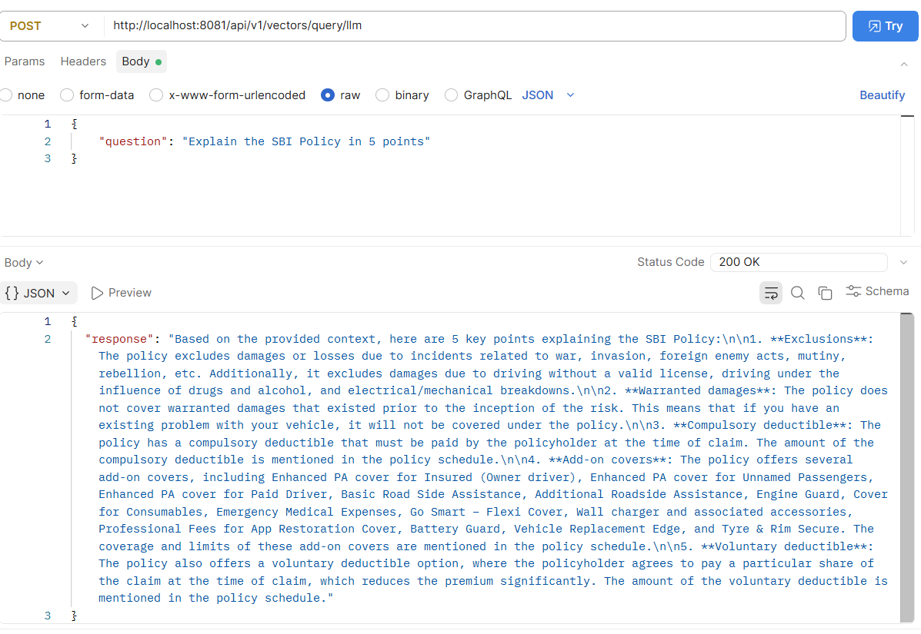
- Observations from the POC
- Embedding model choice wasn't a one-shot decision
- Started with AWS Bedrock, moved to Salesforce Einstein when scope changed, ended up on Ollama when Einstein wasn't working
- Ollama's biggest advantage: fully local, no API key or cloud account setup needed good for POC/dev work
- Sample document is stored directly in main resource folder in this poc but in prod we can store it in file management systems like ftp/sftp or pass file data as request payload using content type called multipart/form-data
- Trade-off to note: local models won't scale the same way as managed cloud embedding services in production
- Each model switch meant re-checking vector dimensions to keep the schema aligned
- Local environment setup had more friction than expected
- Postgres doesn't listen on TCP by default in every setup needed to check service status, listen_addresses, and pg_hba.conf
- pgvector isn't bundled with every Postgres version had to source a precompiled binary for PostgreSQL 18 on Windows manually
- pgAdmin didn't auto-register the local server needed manual server registration on first use
- Embedding vs. chat model mismatch in the connector config
- Hit a 400 error testing an embedding-only model (nomic-embed-text) against a Text Generation connector config
- Root cause: embedding models and chat/generation models are fundamentally different and need separate connector configs
- Key lesson: confirm whether a model is embedding-only or chat-capable before wiring it into any connector operation
- Tested on a small POC-scale dataset not validated for production-scale data volumes.
- Postgres Isn't Enough because of scaling limits instead we can dedicated vector DBs (Pinecone, Milvus, OpenSearch) in production
- Conclusion
This POC showed that building a vector database on top of Postgres using pgvector is a practical, low-overhead way to get started with AI-powered search and RAG workflows in MuleSoft without needing a dedicated vector database service. Using Ollama for local embeddings made the setup entirely self-contained, with no cloud accounts or API keys required, though this trade-off means it's better suited for development and experimentation than production scale.
The real value of this exercise came from the friction points along the way environment setup, model compatibility, and connector configuration which are rarely covered in high-level tutorials but matter a lot in practice.
For teams already comfortable with Postgres, this is a solid starting point before evaluating dedicated vector databases like Pinecone, Milvus, or Qdrant for production use cases.
If you're exploring similar AI integrations on MuleSoft, feel free to connect or share your own experience always happy to exchange notes.



